**Brooklyn torah gazette**

**For parshas shoftim 5780**

Volume 4, Issue 46 (Whole # 198) 2 Elul 5780/ August 22, 2020

**Printed L’illuy nishmas Nechama bas R’ Noach, a”h**

**19 Facts You Should Know About Sephardic Jewry – Part 1**

**By** [**Menachem Posner**](https://www.chabad.org/search/keyword_cdo/kid/12145/jewish/Posner-Menachem.htm)

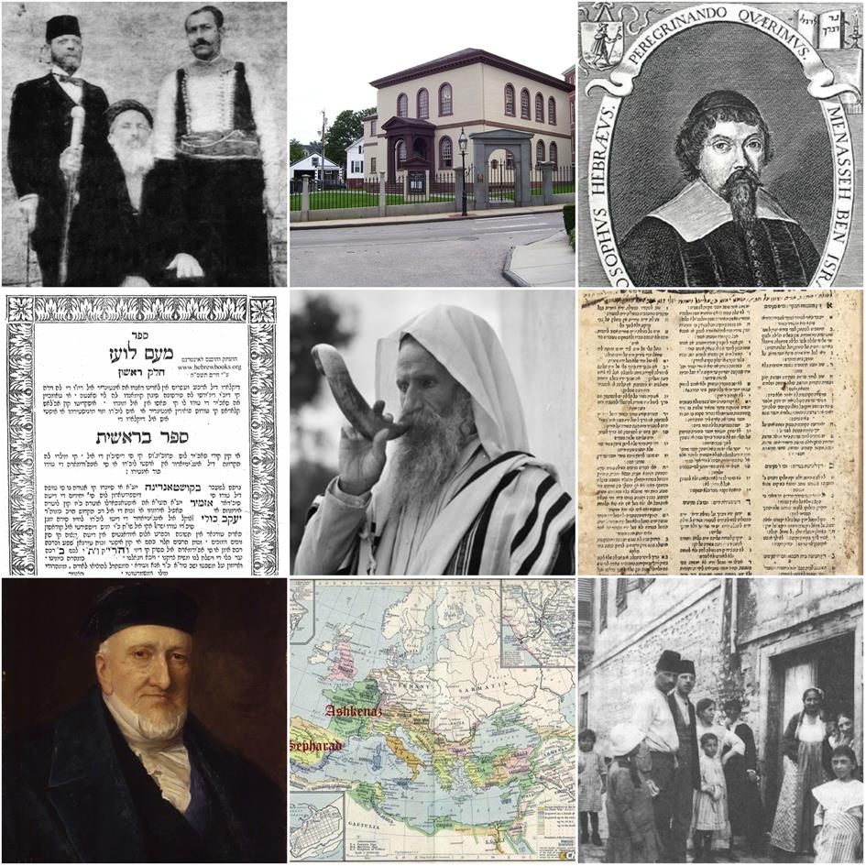

**1. Sepharad is the Ancient Hebrew Word for Spain**

Since Biblical times, the Jewish people have referred to Spain as Sepharad. We see this in the Book of Obadiah, where we are told that “the exile of Jerusalem which is in Sepharad shall inherit the cities of the southland.” Where is Sepharad? The Targum Jonathan identifies it as “Espamia,” Spain. Thus, the Jewish people living in Spain and the Iberian Peninsula (as well as their descendants) became known as Sephardim.

**2. Sephardic Culture and Scholarship Rose in the 10th Century**

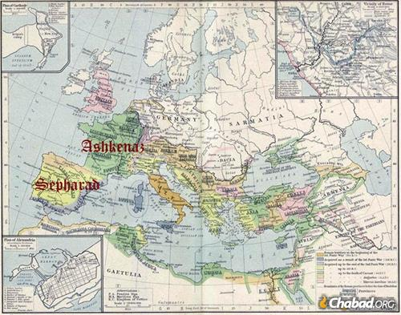

After the decline of the Jewish communities in the Holy Land and Babylon, Jews found new life in Europe, where they blossomed into Ashkenaz and Sepharad.

Even though Jews had been living there for centuries, in the 10th century the Jews of Spain took a leading role in guiding the spiritual and cultural development of the Jewish people as a whole, in large part due to the influence of Rabbi Chasdai ibn Shaprut, a wealthy scholar, physician and statesman. Under his stewardship, Cordoba became a thriving center of Jewish life and learning. At that time, Spain was an Arabic-speaking Muslim land, and Jews took part in the explosion of scientific and linguistic scholarship that abounded.

**3. Sepharad Soon Spread All Over**

In the mid-12th century, much of Spain was overrun by the Almohads, a sect of fanatical Muslims. Many Sephardic Jews fled to avoid forced conversion to Islam, planting the seeds for the Sephardic diaspora that would flourish around the world.

Among the best-known Jews forced to leave Spain at that time was Maimonides, who was born in Cordoba and later gained acclaim as one of the greatest Jewish scholars and philosophers of all time in his adopted homeland of Egypt.

**4. Jewish Life in Spain Effectively Ended in 1492**



Isabella and Ferdinand are known for completing the Reconquista, ordering conversion of the Jews and Muslims in Spain.

Despite the oppression of successive Muslim and Catholic rulers, Jews continued to form an integral part of Spanish life. In 1492, however, Ferdinand and Isabella expelled all Jews who refused to convert to Christianity. Hundreds of thousands set sail for Morocco, Portugal, Turkey and beyond, and those who remained were forced to hide their Jewish identity.

The Spanish exiles became prominent in their new homes, and often greatly influenced (and sometimes overshadowed) the communities that had existed there prior to their arrival. As a result, Jews from lands far from Spain are known as Sephardim. Since the big-tent Sepharad includes many more Jews than just the Spanish refugees and their descendants, a more accurate term for Jews of eastern provenance that has gained popularity in recent years is Eidot Hamizrach (“Communities of the East”).

**5. Ladino Is the Lingua Franca of Sephardic Jewry**

Many of the Sephardic exiles and their descendants proudly clung to the beautiful culture they had developed in Spain. Thus, even 500 years later, there are still Sephardim who speak Ladino, the Jewish version of Spanish, which contains many Hebrew words (and has since incorporated many others picked up from Arabic, Turkish and Slavic speaking neighbors). Like Yiddish, Ladino is written in Hebrew characters with its own system of spelling.

**6. The Safed Kabbalists Were Sephardim**

Following the composition (and publication) of the Zohar, the most significant advancement of the Kabbalah was due to the prolific and Divinely inspired teachings of the cadre of Kabbalists who lived in 16th-century Safed (Tzefat).

These men were all Sephardim. Even the Arizal, who was sometimes called the Ashkenazi Rabbi Isaac, was the son of a Sephardic mother and was raised by his Sephardic uncle, Mordechai Frances of Cairo.

Read: [Safed and the Attempt to Revive Semichah](https://www.chabad.org/library/article_cdo/aid/2435047/jewish/Safed-and-the-Attempt-to-Revive-Semicha.htm)

**7. Sephardic Communities Were Decimated by the Holocaust**

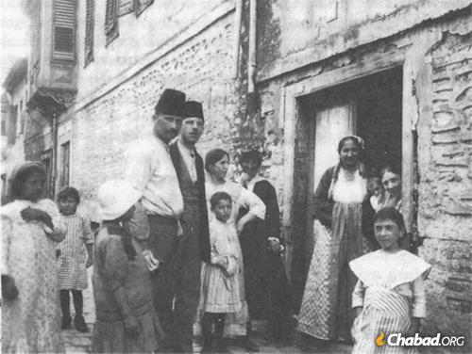

A large and lively Sephardic community once lived in Thessaloniki, Greece.

Most contemporary Sephardic Jews hail from Turkey, North Africa and the Middle East, places that were largely unscathed by the Holocaust. However, there were once thriving Sephardic communities in Greece, Italy, the Balkans, and Romania, which were almost completely decimated by the Nazis and their local collaborators.

Cities like Thessaloniki (once referred to in Ladino as La Madre de Israel, “Mother of Israel), were bereft of their Jewish denizens, with few survivors left to carry on their rich traditions.

**8. Persians, Yemenites, and Others Are Not Sephardim**

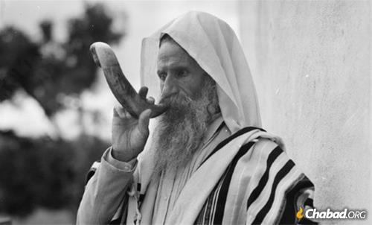

**A Yemenite Jew blows shofar (circa 1930s).**

People rarely fit neatly inside the boxes we try to squeeze them into, and many cultures that are mistakenly (and conveniently) placed under the rubric of Sepharad are actually not Sephardic at all. Some examples are the Yemenite Jews, whose unique Jewish tradition is even more ancient and did not come by way of Spain; Persian Jews, who speak Judeo-Farsi and trace their lineage to the Babylonian exiles; indigenous Italian and Greek Jewish communities, whose culture lies somewhere between Ashkenaz and Sephard with plenty of unique elements; as well as the Mustarabim, Jews native to Arabic lands, who were were overshadowed by and merged into the Sephardic majority.

(*Reprinted from this week’s email of Chabad.Org Magazine. To be continued in next week’s email edition*).

**Rabbi Berel Wein**

**On Parshat Shoftim**

**By Rabbi Berel Wein**

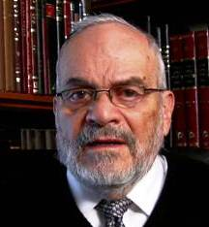

It can be said that the Torah is in favor of law and order. In this week's reading, the Torah prescribes a system of judges, courts, and police. The Torah apparently takes it for granted that no society can really function without these institutions of law and protection. The Torah warns us that these institutions must be ones of righteousness, fairness, and even altruism, but they must exist for society to function.

Amongst the ideological foes of Jewish life and values, the idea of anarchy – no government, no police, no courts – ranks as one of the most pernicious and evil of enemies. The nature of people is to be contentious, protective, and zealous of one's own property, personal rights, and privileges.

**Disputes will Certainly Arise**

Since, by nature, human beings always encounter other human beings which is the basis for all commerce and social interaction, disputes will certainly arise when one's rights butt up against the perceived rights of others. How are these matters to be settled?

In a lawless society, brute strength and violent behavior would always prevail. But the Torah constantly reminds us that we are to protect and enhance the rights of the poor and defenseless, the widow and the stranger, those that are, somehow disadvantaged by the process of general society. And it becomes the task of the legal system that is established in Jewish society, to protect these individuals. Judges and police, courts and bailiffs are not only necessary for society, but are also the agents of Godly intent.

**All Legal Systems are Inherently Flawed**

All human history has shown us that all legal systems established by human beings are inherently flawed and subject to manipulation. We read in the book of Psalms of the complaint that evil can be easily constructed by legal means. Even a cursory study of the prophets of Israel will reveal the extent of their condemnation of the perverse practices and corruption of the court systems and the judges of their generations.

It is hard, if not well-nigh impossible .to find people who are completely incorruptible. All of us have human weaknesses that can be exploited by others and manipulated by any form of legal system that we will devise. Our great teacher and leader, Moshe, could not find, even in his generation, judges and tribal leaders that would meet all the requirements that were set for them by Yitro and confirmed by heaven itself. He, so to speak, had to settle for what was available to him in Jewish society at that time.

**Beware of Searching for Perfection**

There is a lesson in this for us - that we should not allow our search for perfection to disqualify people who otherwise could serve as competent and efficient judges and administrators of Torah law. That is what the Talmud meant when it said that Yiftach in his generation was the equal of Samuel in his generation. We can only deal with what exists before us.

The Torah cautions us that the only judge that you have is the judge that exists in your generation. Thus, the basis of all legal systems is practicality, and the Torah is the most practical of all disciplines.

*Reprinted from this week’s website of Rabbiwein.com*

**Parshas Re’eh**

**The Religion of Evolution –**

**Just Keep the Faith**

**By Rabbi Bentzion Shafier**

**Founder of TheSmuz.com**



ספר דברים פרק טז

(יט) לא תטה משפט לא תכיר פנים ולא תקח שחד כי השחד יעור עיני חכמים ויסלף דברי צדיקם:

רש"י על דברים פרק טז פסוק יט

**ולא תקח שחד** - אפילו לשפוט צדק:

**כי השחד יעור** - משקבל שוחד ממנו אי אפשר שלא יטה את לבבו אצלו להפך בזכותו:

“*You shall not pervert judgment, you shall not respect someone’s presence, and you shall not accept a bribe, for the bribe will blind the eyes of the wise and make just words crooked*.” – Devarim 16:19

**The mitzvah of Appointing Judges**

The Jewish nation as a totality was given the *mitzvah* of appointing judges. These judges were commanded to mediate with righteousness according to the Torah’s laws. One of the rules of a judge is that he may not accept a bribe because a “*bribe will* *blind the eyes of the wise.*”

Rashi is bothered by a question: the Torah already commanded the judges to rule honestly with the expression, “*Do not pervert justice.*” There is no need for a second prohibition against accepting bribery. The purpose of a bribe is to cause the judge to ignore the truth and change the verdict. That is certainly included in the requirement of not perverting justice. So why does the Torah write a second prohibition specifically warning judges not to accept bribes?

**Rashi Answers the Prohibition**

**Of Judges Acception Bribes**

Rashi answers that the prohibition of not accepting bribery refers even to cases in which the judge fully intends to rule fairly. If a *shofet* plans to accept a bribe but not to allow it to influence his decision, the Torah forbids him from doing this. The nature of bribery is to pull his heart, and it is impossible to remain unbiased once he has received a bribe. The Torah is teaching us that even if he wants to judge honestly, it will be impossible for him to do so because once he accepts a bribe, against his will he will favor the one who bribed him.

This Rashi is difficult to understand. Assuming we are dealing with an experienced, skilled judge who is well-versed in law and the proceedings, why can’t he accept a bribe and still judge honestly? The facts are the facts. Either the man is guilty or innocent. Either he owes the money or he doesn’t. Why can’t a judge make up his mind that the money is the money, but I will not allow this to affect my ruling in this case?

**The Wind Made It**

The answer to this question can best be understood with a *moshol*. Imagine that you find yourself in a junkyard in the backwoods of Tennessee. You look around and see piles and piles scrap: old refrigerators, a rusted-out stove top, entire cars demolished. Everything is all strewn about without any order. Then suddenly you see something out of place: a brand new Dell laptop computer — red color, no less. You pick it up and you see that it is unscratched and in perfect working order. You turn to the owner of the junkyard, a rather primitive fellow, and innocently ask, “Where did this come from?”

“Oh,” he responds. “I don’t know if you heard, but we had us some fierce winds here last night.”

**“Fierce Winds?”**

“Yeah, some real gusters. I came this morning and things were all blown about, and then I saw that there computer, so I rightly figured that the winds just sort of blew the pieces together.”

You look at the fellow incredulously and ask, “The wind blew the pieces together?”

“Yeah, you know they just sort of blew a piece from over here, and then a piece from up there, and before you know it, we have this here computer.”

At that point, you say to the man, “Sir, I don’t mean to be rude, but there is a monitor and a fully functioning mouse. I turn it on, and the fan kicks in. And the keyboard! How do you explain the keyboard? Look at it, QWERTY, in perfect order!”

“Listen, fella,” he responds. “I’m not saying it’s likely. I’m just saying things happen. There was a huge nor’easterner last night, it blew things all around, and this is what happened.”

**The Man is Clearly**

**Not Speaking Sense**

At this point, you recognize that there is little point in continuing the discussion because the man clearly isn’t speaking sense.

This is a very apt *moshol* to phenomena that we regularly experience. We will have conversations with intelligent, well educated people who will tell you that the world evolved. Everything that you see, from the flower to the bee, from the oceans to the mountains, rivers, planets, the sun, the moon, and the stars, all just sort of happened.

No designer. No Creator. It just began with a Big Bang and all of the wonder of this infinitely complex world came into being. The uniformity, the complexity, the harmonious systems, the universal laws of physics, just happened. Just a lucky roll of the cosmic dice and a hundred billion galaxies, each one containing a hundred billion stars – just occurred. It becomes very difficult to argue against such a position. Where do you begin?

But if we carry the *moshol* to its next step, we see the question deepens dramatically.

**Who Wrote the Code?**

A computer doesn’t have a brain. It is a machine that processes data as directed by software programs. That software is actually coding. Beginning with the most basic commands all the way up the most complex, software engineers write line after line of code. If this, then that. If this, than that. . . The writing of code is very time consuming and tedious, and it must be exact. One mistake in the flow of logic, and the program hits a dead end.

When the computer industry was young, software programs were measured in the amount of hours it took to develop them. 100 hours? 200 hours? As the industry developed, the programs became so complex that single individuals could no longer write them; entire teams had to be dedicated towards the task.

Now they no longer could be measured in hours, but estimated in man years. Assuming that we put a team of twenty programmers to work full-time on this project, how many years will it take them to complete it? 10 man years? 20 man years? The software that runs today’s computers is based on compilations of thousands of man years of coding.

Now let’s go back to our *moshol*. Imagine that we were to ask the junkyard owner a very pointed question: “I will grant you the monitor and the six cell battery. I’ll even give you the four-color Windows decal on the keyboard. But who wrote the code? Who programmed the thing? When you turn on that laptop and launch a program, hundreds if not thousands of man years of programming went into that software. Where did it come from? Did the wind sit there and write line after line of complex, intricate instructions? Who wrote the code?”

**The Religion of Evolution**

The *nimshol* of this is that the same people who tout evolution as a religion are also aware that physical life itself has exact rules. Every cell in the human body is directed by the DNA coding. The simplest amoeba is far more complex than any machine ever devised by man. A human baby is so much more infinitely complex than an amoeba that it defies a relationship. The trillions and trillions of cells of the body are all specific, all organized into organs and systems with each one perfectly in place, each one playing its part. How can anyone possibly think that it just evolved? Who wrote the code?

The answer to this is quite simple: HASHEM created man with free will, free will to believe or not to believe, to accept or not to accept. With the capacity called free will was included this most amazing ability to accept the most far-fetched, ludicrous positions as long as it fits into my agenda.

**A Brilliant and Wise Human**

**Still Has Weaknesses**

This seems to be the answer for Rashi. The Torah is teaching us that the human may be brilliant and wise, but he has a weakness. His pure judgment can be easily influenced. If a man accepts a bribe, it will color his vision. He will lose his detached sense of judgment and will no longer be able to rule objectively. He may think that he won’t be influenced, but it is human nature to be pulled, and he will no longer be capable of objective clarity. He will be blinded.

The application of this Torah concept is clear in what we witness today as the blindness of man staring into the brilliance and wonder of Creation and mouthing the words, the “wonders of evolution.”

*Reprinted from this week’s website on TheShmuz.com This is an excerpt from the [Shmuz on the Parsha book](https://theshmuz.com/product/shmuz-on-the-parsha-book/).*

**The Eternal G-dly**

**Soul of the Jew**

**From the Talks of the Lubavitcher Rebbe**

**Rabbi Menachem Mendel Schneerson, Zt”l**

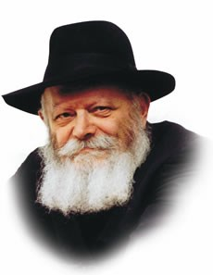

"At the mouth of two witnesses, or three witnesses, shall he who is worthy of death be put to death, but at the mouth of one witness he shall not be put to death," we read in this week's Torah portion, Shoftim.

But what happens if someone confesses to a capital crime? Is the Jewish court allowed to carry out a death sentence, according to the rule that "the admission of the plaintiff is worth 100 witnesses"?

Maimonides explains that this legal ruling applies only in monetary cases; when it comes to capital crimes, two witnesses are necessary to determine guilt.

Our Sages explain the difference thus:

A person's soul is not his property; it does not belong to him at all, but is only entrusted to him by G-d for safekeeping. For this reason it is not only forbidden to kill (oneself or others) but it is forbidden to cause harm or injury to the body, as well. An admission of guilt is therefore meaningless because it involves something which is not subject to ownership.

Wealth, on the other hand, is actually "owned" by the individual (as much as anything created by G-d, the Master of the world, can said to be "owned" by a human being). The testimony of the person involved may therefore be accepted as the determining factor.

**The Benedictions of Enjoyment**

This distinction is also reflected in the various blessings established by our Sages, appropriately called "benedictions of enjoyment."

We recite a blessing before eating or drinking, but not before enjoying our money. That is because the soul, which derives its pleasure and sustenance from the divine sparks in the food or drink we ingest, is not our own; we must therefore recite a blessing before we partake of G-d's goodness. However, we do not need to obtain G-d's permission before we spend our money. (Of course, G-d wants us to utilize our wealth for doing mitzvot, giving charity, etc.)

In truth, every single Jew is a "witness," for his observance of Torah and mitzvot attests to the existence of the Creator. The function of a witness, in both the limited and broader sense, is to uncover something which is hidden.

G-d has placed the Jewish people in a physical world ("olam," from the word meaning hidden or concealed) to testify to His absolute sovereignty, and show through their actions how "everything came into being with His word."

**The Messianic Era**

When this will take place, the above type of testimony will not be necessary, for we will have entered the Messianic era and G-dliness will be self-evident:

"The glory of G-d will be revealed, and all flesh will see that the mouth of G-d has spoken." May it happen immediately.

*Adapted from talks of the Rebbe*

*Reprinted from the Parshat Shoftim 5755 edition of the L’Chaim Weekly, a publication of the Lubavitch Youth Organization.*

**Don’t Delay**

**By Rabbi Moshe Meir Weiss**

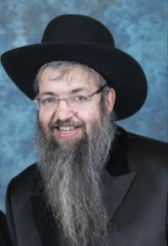

Imagine, if one was to gather the ultimate anthology, he would go to Rav Shwadron, Zt”l, and ask him to sift through all of his teachings and choose the most powerful one. Then, he would go to Rabbi Yissacher Frand, Shlit”a, and ask him to look through his drashos and relate the one statement he has made during his career that he feels made the biggest impact upon his audiences.

Then, he would go to Rav Yisroel Reisman, Shlit”a, and ask for his most riveting teaching. He would then listen to all of the tapes of Rabbi Avigdor Miller, Zt”l, and hand pick the single, most-timely message. Finally, he would do this with all the greatest teachers of the last one hundred years.

Wouldn’t we drool over the chance to learn from such a compilation? How we would drink from its wisdom and try to emulate its ethics and morals.

**We Have Such a Precious Sefer**

In truth, we have such a sefer and it is infinitely more precious, Pirkei Avos. It contains the greatest sayings of the greatest Sages of the Tannaic period. For example, Shimon HaTzaddik was so-called because he was the most righteous person of his generation and, in Pirkei Avos, there is but one Mishna recording his teachings.

We can imagine that Shimon HaTzaddik, the preeminent tzaddik of his generation and the Kohen Gadol, spent a lifetime educating the masses and directing them to a life of Torah and morality. Yet, there is only one Mishna of his lessons. Thus, Pirkei Avos contains the crème de la crème of the most outstanding sages of that most extraordinary era of Torah knowledge.

With this in mind, we should have great excitement, exhilaration, and thirst, when we open up the rarified teachings of Pirkei Avos.

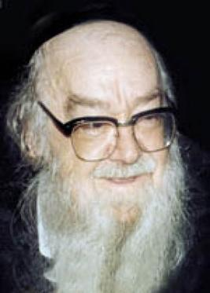

***Rabbi Sholom Schwadron, zt”l***

**Let’s Choose One Lesson**

Let’s choose one lesson from this lofty collection. In the Second Perek of the Mishna, Hillel says, “Al tomer lichshe’efneh eshneh, shema lo tiponeh – Don’t say when you will have leisure you will study, for perhaps you will never find the time.”

This Mishna reveals to us one of the most potent weapons of the Yeitzer Hara, the evil inclination. His ability to thwart people from a life of Torah and mitzvahs through the device of procrastination. He suggests to a working father/husband, ‘Listen, you can’t learn now. You’re busy supporting a family. You need to make ends meet. And then of course, you need to relax a little. Otherwise you’ll end up in the hospital. There’ll be plenty of time to learn when you retire.

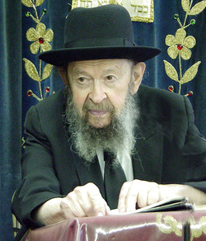

**Rabbi Avigdor Miller, zt”l**

**The Myth of One’s Golden Years**

“Don’t worry, in your golden years you’ll sit in a Beis HaMedrash in Netanya or in Miami Beach and study loads of Torah.’ And sadly, when our husband/father retires, his eyes are failing, his memory is waning, his concentration is not what it used to be, and his sitzfleisch (ability to sit in one place) is not there.

How sad that he lost all the precious years when he was in full strength to utilize all of his senses for our main mission on earth and the eternal essence of life which is the study of Torah.

Sometimes, the Yeitzer Hara pushes us off until the summer – and then in the summer he tells us that we need to rest in order to re-charge our batteries before the coming winter. Other times he says to wait until Shabbos, but then, after the heavy meals and after the long hard workweek, the body just caves in – and he wins again.

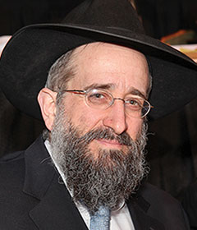

**Rabbi Yisroel Reisman**

He uses this trick also when it comes to such campaigns as being marbeh sedra, that all-important Jewish charge to review the Torah portion of the week. He tells us, ‘Listen, it’s the middle of the year already. You don’t like to do things in halves. So, start next time by parsha Bereishis. Next year you’ll do it, you’ll see.’

How many times have we been fooled by that trick? Let’s respond to the Yeitzer Hara, ‘You know what, I’ll start now. After all, these are the parshios of Bamidbar and Devarim that I didn’t learn so well in yeshiva.’ Or tell him urgently the convincing argument, ‘I’ll start now and I’ll have finished the whole Torah by this time next year.’

**What About the Daf HaYomi?**

What about Daf HaYomi where so many people are fooled by him to think that they have to wait until the world starts Masechtas Berachos. That’s ridiculous. Anytime you start Daf HaYomi, you finish Shas in seven and one-half years. What a wise move to start now and get Masechtas Eruvin with the rest of the Daf Yomi olam.

But, this sagacious advice is not just reserved for the study of Torah. It is true for all the mitzvahs as well. Chazal teach us the fundamental lesson, “Ein attah ela lashon teshuva – The word attah (spelled with an ayin, meaning now) only refers to repentance.”

**You Have to Seize the Moment**

This vital saying teaches us that, if you want to change and turn over a new leaf, you have to seize the moment when the thought of teshuvah crosses your mind and act upon it immediately. If not, the Yeitzer Hara will successfully stall and delay until the routine of life distracts you from your resolve.

Let’s take a common example. You open up your Siddur and you say the daily psalm, and you realize that you don’t know what you’re saying. You simply don’t know the meaning of the words. With chagrin, you say to yourself, ‘I better learn the translation of this.’ Don’t succumb to pushing it off to an undetermined later date. Look at the English translation there and then and seize the moment!

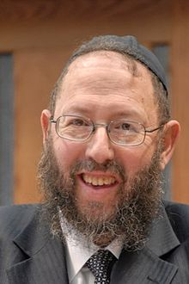

**Rabbi Yissocher Frand**

When you bow down at Modim in the middle of Shemone Esrei and jog yourself from your day-dreaming and you ruefully think to yourself, ‘One of these days I’d better start having kavanah,’ don’t let yourself postpone such a fine attitude. Rather say, I’ll start right now with the rest of Shemone Esrei and Ashrei, U’va L’Tzion! This is the only way to improve, to act upon it as soon as the thought comes to your mind – before the Yeitzer Hara can reestablish the status quo.

This rule holds true for all the other mitzvahs as well. Bocherim, when it comes to Kivud Av v’Eim, don’t say, ‘One of these days I’d better start calling my parents or writing them letters.’ Start now!

**Advice for Husbands and Wives**

Husbands and wives. Don’t muse to yourself, ‘You know, I gotta get around to putting more effort into my marriage.’ Do it now! Go out and buy a gift for your spouse. Give a compliment or a helping hand. Don’t let the Yeitzer Hara push it off.

The same thing is true for our responsibility to the children. Don’t let the Yeitzer Hara deceive you into thinking that when the economy gets better you’ll have more time or when they get older it will be easier. These are all just tricks of the Sly One.

May it be the will of Hashem that we succeed in acting with alacrity to improve our Torah and mitzvahs and, in that merit, may Hashem bless us with long life, good health, and everything wonderful.

*Reprinted**from the Parshat Eikev 5780 email of Oneg Shabbos (United Kingdom) Originally published in the TorahAnytime.com Newsletter.*

**How Israeli Researchers**

**Are Helping the World**

**Combat Covid-19**

**By Daniel Keren**

(“Tikun Olam: Israel vs Covid-19” by Jodie Cohen, 125 pages, paperback, 2020, Minterne Publications)



Seven months ago, when anyone have imagined just how the world we knew would be so dramatically turned upside down by an infectious disease. For months most of the country’s population was quarantined in home, and unfortunately tens if not hundreds of thousands of businesses went out of business because of long closures.

**The Tragedy of Covid-19 Lost Lives**

Tragically more than 100,000 Americans lost their lives and many more are now still recuperating from by the Corona virus or Covid-19 disease, perhaps the worst pandemic since the infamous Spanish Influenze of 1919. Once this terrible megayfa (plague) comes under control when vaccinations are developed, the world will still be dramatically different from what it was before Covid-19 broke out in the early part of this year.

**A Nation that Dwells Alone**

More than 3,000 years ago, the wicked non-Jewish prophet Bilaam declared to his patron Balak that the Jewish people are “a nation that dwells alone.” To this day, the Jewish people have for the most part been reviled by the non-Jewish world despite the many contributions we have made to the host countries were we have sojourned during our long golus (exile).

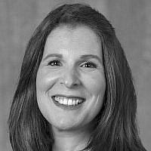

**Jodie Cohen**

Since its establishment in 1948, the Jewish State of Israel, the only true democracy and humanitarian nation in the Middle East, has been unfairly maligned by much of the world.

**The Spirit of Tikkun Olam**

In an attempt to demonstrate how the Jews in that embattled nation are still inspired the many millennium-old spirit of Tikkun Olam (repairing the world,) Ms. Jodie Cohen, an award-winning public affair consultant with a current focus on helping those companies report on how they are contributing to the United Nations’ Sustainable Development Goals, especially in the area of good health and wellbeing has just written a 125-page paperback titled “Tikkun Olam: Israel vs Covid-19.”

The author’s aim is to demonstrate just how many Israelis in that now famous “start-up nation” have quickly transformed their incredible innovations to heal the world, especially in these terrifying days of the Covid-19 pandemic.

Ms. Cohen has selected 30 different innovations that have been developed by Israeli scientists, doctors and CEOs during the brief period of the outbreak of the deadly infectious disease and early May of this year have been transformed in an attempt to find solutions of Covid-19.

**Efforts of Israeli Hi-Tech Start-Ups To Deal with the Covid-19**

Among those efforts are attempts by these Israeli hi-tech researchers and innovators to turn mobile phones into potentially lifesaving devices; developing water and solar technologies to provide clean water for washing hands in rural areas of Africa and other Third World regions with current sources of safe water; creating methods to speed up Covid-19 diagnoses; ways to provide free medical advice to Covid-29 patients around the world; the mechanism to donate millions of hydroxychloroquine sulfate tablets to hospitals around the world; and the creation of potentially life-saving antibiotics.

An important caveat or warning to the reader from the author follows:

“This is not a book for those seeking official healthy information about the virus, and no healthcare advice is suggest within. For healthcare information and advice, it is recommended to consult with our local healthcare providers.

“No claims are made predicting the future success or otherwise of any of the innovations detailed within this book, though many are already in use in major hospitals or in the various stages of testing.

“The purpose of this book is to show how the people behind Israel’s ‘start-up nation’ are quickly adapting their innovations in a bid to help ‘tikkun olam,’ or heal the world.”

“Tikkun Olam: Israel vs Covid-19” by Jodie Cohen might be found in local bookstores or can be ordered on websites such as Amazon.

*Reprinted from this week’s edition of The Jewish Connection.*

**Thoughts that Count**

**For Parshat Shoftim**

*You shall be perfect with the L-rd your G-d* (Deut. 18:13)

Just as it is important to safeguard one's physical health, a Jew must take steps to ensure that his soul is whole and that all his spiritual "limbs" are healthy.

For just as there are 613 components in the human body -- 248 limbs and 365 sinews -- so too are there 613 parts of the Jewish soul whose state of perfection is dependent on observing the 613 commandments of the Torah. *(Likrat Shabbat)*

*You shall appoint a king over yourself* (Deut. 17:15)

The inner intent of this commandment is to instill in the Jewish people a sense of nullification before G-d and acceptance of the yoke of heaven. For a Jewish king is completely nullified before G-d; submitting to his sovereignty contains an element of nullification before G-d as well.*(Derech Mitzvotecha)*

*Reprinted from the Parshat Shoftim 5755 edition of L’Chaim Weekly*